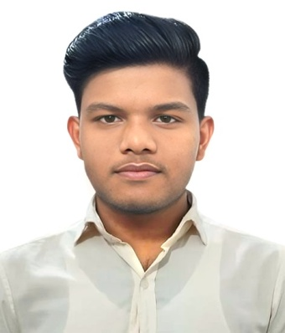**CURRICULUM VITAE**

of

**PRINCE SARKER**

Cell Phone:+8801734291730

|  |
| --- |
| **CAREER OBJECTIVE** |

Email:princesarker676@gmail.com

Looking for a hard and challenging job where I will have the scope to utilize my potentially creative, adaptability and skill to do something innovative and from where I will br able to enhance my knowledge.

|  |
| --- |
| **ACADEMIC QUALIFICATIONS** |

* Diploma in Engineering
  + Institution :Sylhet Polytechnic Institute
  + Board :BTEB
  + Session :21-22
  + Technology :Mechanical
  + Result :Running
* Secondary Scool Certificate(S.S.C.)
  + Institution :Shahid Ali model high School
  + Board :Sylhet
  + Group :Humanities
  + Result :G.P.A.-4.56 (out of 5.00)
  + Year of Passing :2021

|  |
| --- |
| **SKILLS** |

* Automotive Mechanics.(Level-01)By BTEB
* Machine Shop Practice .(Level-03) By NSDA
* Computer Skills-
  + MS Word ,MS Excel,MS Power Point
  + Browsing System (Google Chrome)

|  |
| --- |
| **LANGUAGE** |

* English(Speaking,Listening,Writing and Reading ability)
* Bengali(Mother Language)

|  |
| --- |
| **HOBBIES** |

* Reading
* Traveling
* Learning

|  |
| --- |
| **PERSONAL INFORMATION** |

* Name :Prince Sarker
* Father’s Name :Setu Ranjan Sarker
* Mother’s Name :Renu Bala Sarker
* Date Of Birth :01-12-2004
* Sex :Male
* Marital Status :Single
* Nationality :Bangladeshi
* Religion :Hinduism
* Present Address :Laladigirpar,Sylhet Sadar,Sylhet
* Permanent Adress :Vill.-Sudhan Khalli,P.O.-Ghungiargaon-3050,P.S.-Shalla,Dist.-Sunamgonj.
* NID No :1974725754
* Blood Group :O+
* Mobile No :01734291730

**I do hereby declard that the avobe information is true and correct to the best of my knowledge.**

Signature:

Date: